

**SERIAL NUMBER STICKER PRINTING SOFTWARE**

**Designed by Karmic Embedded Pvt. Ltd.**

**USER MANUAL**

|  |
| --- |
| CONTENTS |
| logo-2.png   * INTRODUCTION * PRE-REQUISITES * USAGE * SUPPORT |

**INTRODUCTION:**

This software is designed to reduce the workload of production department of our clients by automating the process of naming various devices.It reduces the task of copying and placing the serial number onto the sticker.

**PRE-REQUISITE’S:**



* System with windows XP/07/10 etc
* Python installed onto your PC
* Python libraries

**USAGE:**

1. *Install python onto your windows machine as shown below*

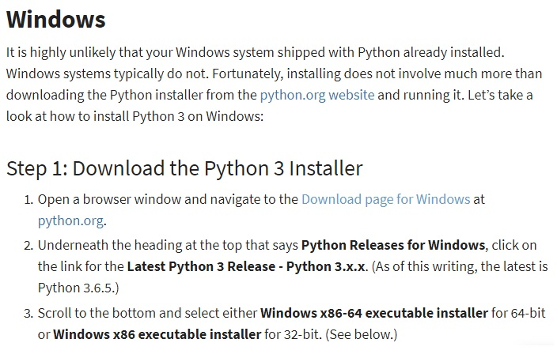

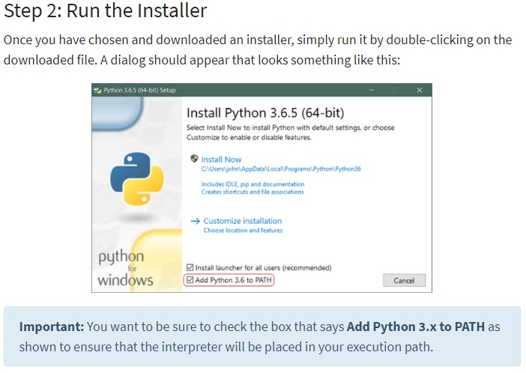

python_install_4.jpg

1. *Copy the software folder onto your C drive.*
2. *Open the Excel file “printerserial” from the folder.*

*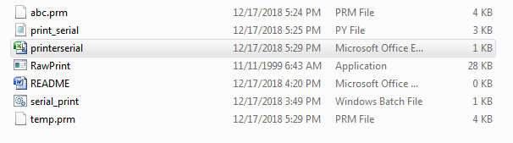*

1. *Now,place the* **country origin** *under* **f1***,*

**Date code** *under* **f2***,*

**no of units** *under* **f3,**

**model** *beneath* **f4***,*

**serial number** *under* **f5** *and* **price** *below* **f6**

*As shown in below figure.*

*Now save the excel file (if asked to replace then hit replace tab)and then, close the excel file.*

*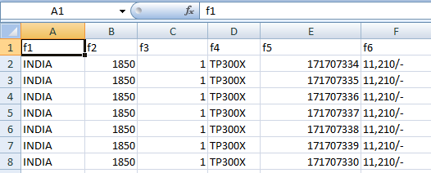*

1. *Next,Create a shortcut of the below shown file on your desktop from the given folder.*

*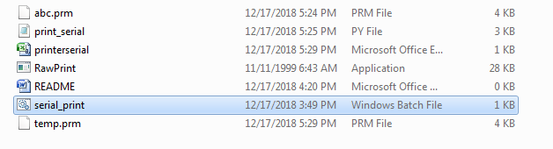*

1. *Now double click the serial print icon.*

*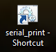*

1. *The software runs and opens a window as shown in below image.*

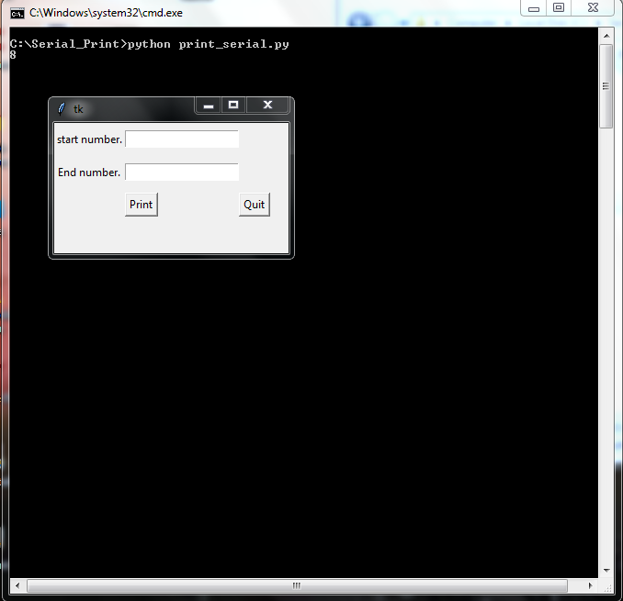

1. *Now enter the serial numbers of which you wish to print the labels .*

*For example: start number:1*

*End number:25*

*Meaning it takes first 25 serial numbers and print the respective labels with associated serial numbers.*

*It also takes range as:*

*Start number:26*

* End number:100*

**SUPPORT:**

**For any queries or any kind of help contact us on:**

* [nikhilp@karmicembedded.co.in](mailto:nikhilp@karmicembedded.co.in)
* [kalpeshm@karmicembedded.co.in](mailto:kalpeshm@karmicembedded.co.in)